MAI 2021

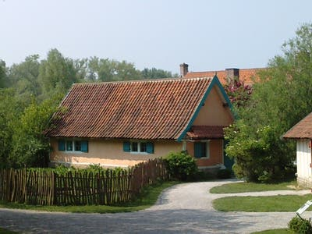

|  |  |  |
| --- | --- | --- |
| *1* | S | Fête du travail |
| *2* | D | Boris |
| *3* | L | Jacques/ Philippe |
| *4* | M | Sylvain |
| *5* | M | Judith 18 |
| *6* | J | Prudence |
| *7* | V | Gisèle |
| *8* | S | Victoire 1945 |
| *9* | D | Jeanne d’Arc |
| *10* | L | Solange |
| *11*  Villeneuve d'Ascq | M | Estelle |
| *12* | M | Achille 19 |
| *13* |  | Ascension |
| *14* | V | Mathias |
| *15* | S | Denise |
| *16* | D | Honoré François André 37 |
| *17* | L | Pascal Nathalie 56 |
| *18* | M | Eric |
| *19* | M | Yves 20 |
| *20* | J | Bernardin |
| *21*  Monument du souvenir | V | Constantin |
| *22* | S | Emile |
| *23* | D | Pencôte |
| *24* | L | Donatien |
| *25* | M | Sophie |
| *26* | M | Berenger 21 |
| *27* | J | Augustin |
| 28 | V | Germain |
| 29 | S | Aymar |
| 30 | D | Fête des mères |
| 31 | L | Visitation |